LAB-25.
Plot the graph of equation y=x²-6 using python.
Input code: 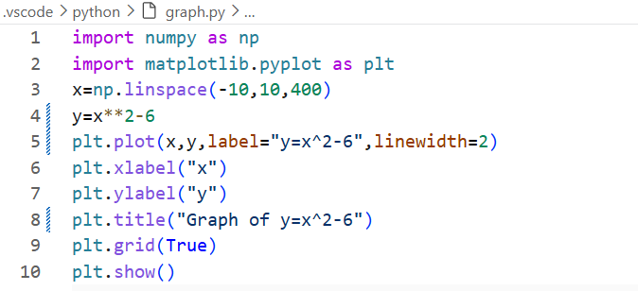
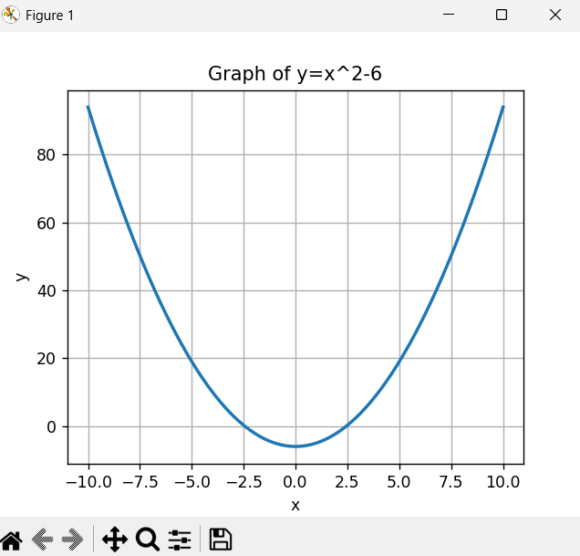
LAB-26.
2.Plot the graph of equation y= sinx using python.
Input code:
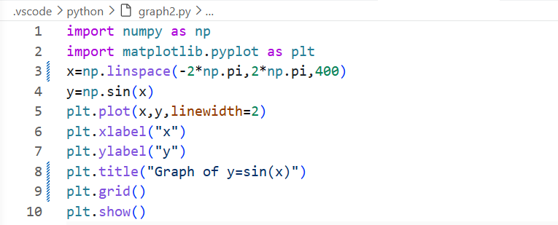
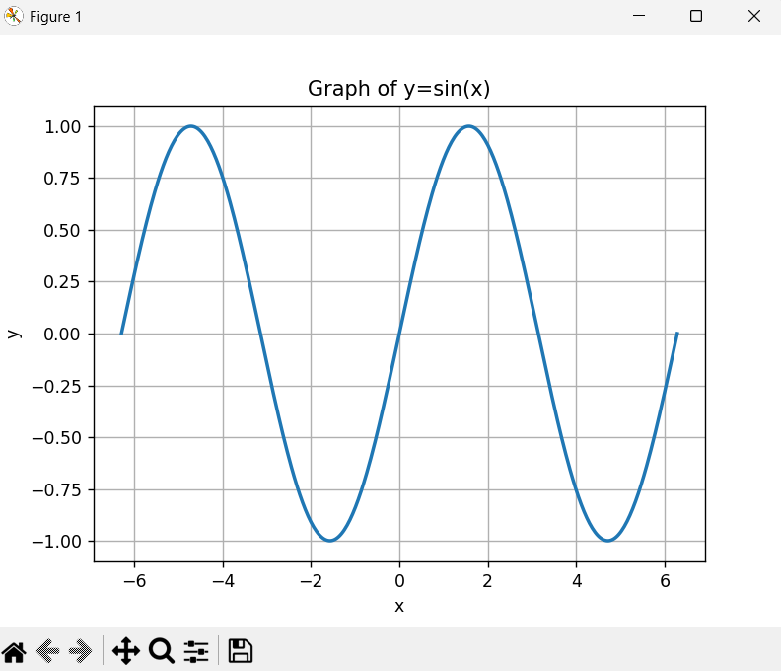

LAB-27.
3.Draw a 3D paraboloid of equation z=2x² +2y² using python.
Input code:
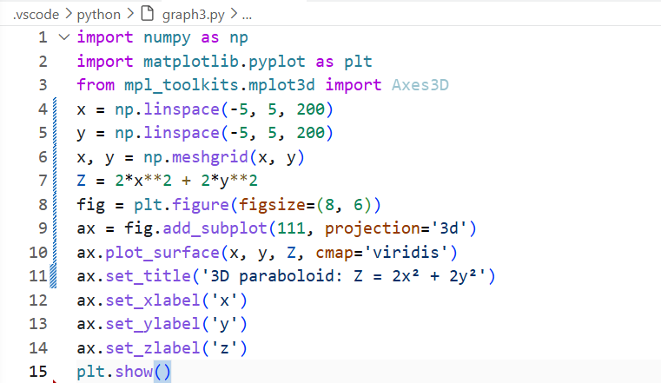
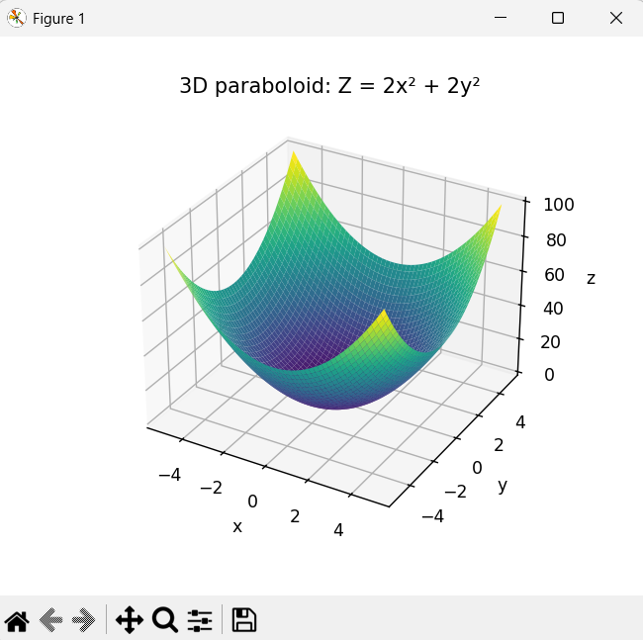
LAB-28.
Compare the graph of equations y=ex, y=ln(x), y=x3 using python.
Input code:
